
Ideation Phase
BrainStrom s Idea Prioritization Template

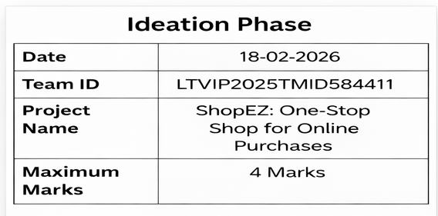
Brainstorm s Idea Prioritization
Reference: https://www.mural.co/templates/brainstorm-and-idea-prioritization
Step 1: Team Gathering, Collaboration s Selecting the Problem Statement
Brainstorming is the launchpad for innovation in the ShopEZ project. It creates a free and open environment where every team member can contribute ideas—no matter how unconventional. This step is all about collaborative creativity and problem discover.

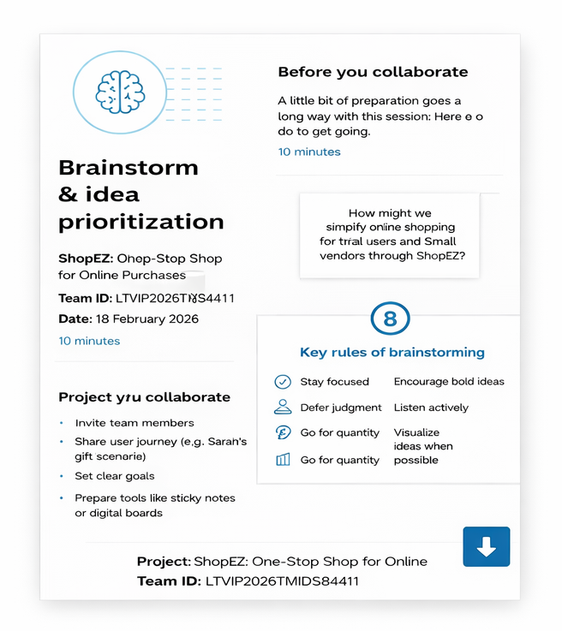

Step-2: Brainstorm, Idea Listing and Grouping
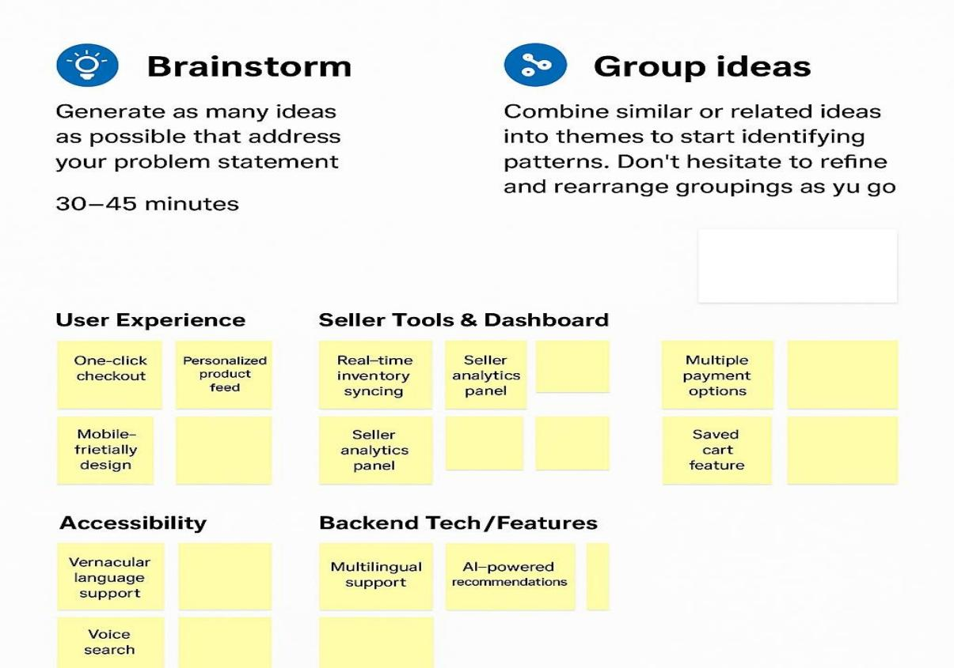
Step-3: Idea Prioritization
